**SIMATS SCHOOL OF ENGINEERING**

**SAVEETHA INSTITUTE OF MEDICAL AND TECHNICAL SCIENCES**

**CHENNAI-602105**

**Sentiment and Behaviour Recognition**

**A CAPSTONE PROJECT REPORT**

*Submitted in the partial fulfilment for the award of the degree of*

**BACHELOR OF ENGINEERING**

**IN**

**INFORMATION TECHNOLOGY**

**Submitted by**

**K. Muni Lakshmi (192210336)**

**K. Pranitha (192210506).**

**Under the Supervision of**

**Dr. E. K. Subramanian**

**July 2024**

**DECLARATION**

We **K. Muni Lakshmi, K. Pranitha** students of **Bachelor of Engineering in Information Technology**, Department of Computer Science and Engineering, Saveetha Institute of Medical and Technical Sciences, Saveetha University, Chennai, hereby declare that the work presented in this Capstone Project Work entitled **Sentiment and Behaviour Recognition** is the outcome of our own bonafide work and is correct to the best of our knowledge and this work has been undertaken taking care of Engineering Ethics.

**K. Muni Lakshmi (192210336)**

**K. Pranitha (192210506)**

Date:

Place:

**CERTIFICATE**

This is to certify that the project entitled **Sentiment and Behaviour Recognition** submitted by **K. Muni Lakshmi, K. Pranitha**

has been carried out under my supervision. The project has been submitted as per the requirements in the current semester of B. Tech Information Technology.

Teacher-in-charge

Dr. E. K. Subramanian

**ABSTRACT:**

Sentiment and behaviour recognition have become critical components in natural language processing (NLP) due to their wide range of applications in areas such as social media analysis, customer feedback evaluation, and mental health monitoring. This study aims to explore advanced techniques for sentiment analysis and behaviour recognition, leveraging deep learning models and natural language understanding to classify and interpret sentiment intensity and behavioural patterns accurately.

We employ a combination of neural network architectures, including Convolutional Neural Networks (CNNs) and Long Short-Term Memory (LSTM) networks, to analyse textual data. These models are trained on comprehensive datasets to understand the nuanced expressions of emotions and behaviours. By integrating sentiment lexicons and contextual embeddings, our approach captures the subtleties of human emotions more effectively.

Additionally, we explore the application of transformer-based models, such as BERT and GPT-3, to enhance the accuracy of sentiment classification and behaviour prediction. These models leverage large-scale pre-trained language representations to understand context, sentiment polarity, and intensity.

Our research demonstrates that combining traditional sentiment analysis techniques with modern deep learning approaches significantly improves the precision and recall of sentiment and behaviour recognition systems. The results show potential for practical applications in monitoring public opinion, enhancing customer service experiences, and providing early warnings for mental health issues.

Future work will focus on refining model architectures, exploring multi-modal sentiment analysis incorporating audio and visual data, and expanding the scope of behaviour recognition to include more complex emotional and psychological states.

The rapid growth of Internet-based applications, such as social media platforms and blogs, has resulted in comments and reviews concerning day-to-day activities. Sentiment analysis is the process of gathering and analysing people’s opinions, thoughts, and impressions regarding various topics, products, subjects, and services. People’s opinions can be beneficial to corporations, governments, and individuals for collecting information and making decisions based on opinion. However, the sentiment analysis and evaluation procedure face numerous challenges. These challenges create impediments to accurately interpreting sentiments and determining the appropriate sentiment polarity. Sentiment analysis identifies and extracts subjective information from the text using natural language processing and text mining. This article discusses a complete overview of the method for completing this task as well as the applications of sentiment analysis. Then, it evaluates, compares, and investigates the approaches used to gain a comprehensive understanding of their advantages and disadvantages. Finally, the challenges of sentiment analysis are examined in order to define future directions.

**Keywords:**

Sentiment Analysis, Behaviour Recognition, Natural Language Processing (NLP), Deep Learning, Convolutional Neural Networks (CNNs), Long Short-Term Memory (LSTM) Networks, Transformer Models, BERT, GPT-3, Sentiment Lexicons, Contextual Embeddings, Mental Health Monitoring, Social Media Analysis

**INTRODUCTION:**

Sentiment analysis has gained widespread acceptance in recent years, not just among researchers but also among businesses, governments, and organizations (Sánchez-Rada and Iglesias [2019](https://link.springer.com/article/10.1007/s10462-022-10144-1#ref-CR192)). The growing popularity of the Internet has lifted the web to the rank of the principal source of universal information. Lots of users use various online resources to express their views and opinions. To constantly monitor public opinion and aid decision-making, we must employ user-generated data to analyse it automatically. As a result, sentiment analysis has increased its popularity across research communities in recent years. Sentiment analysis is also called as Opinion analysis or Opinion mining. We have seen a recent growth in the sentiment analysis task. The various research works in sentiment analysis (Ligthart et al. [2021](https://link.springer.com/article/10.1007/s10462-022-10144-1#ref-CR130)) published an overview on Opinion mining in the earlier stage. In (Piryani et al. [2017](https://link.springer.com/article/10.1007/s10462-022-10144-1#ref-CR168)) discusses the study topic from 2000 to 2015 and provides a framework for computationally processing unstructured data with the primary goal of extracting views and identifying their moods. Several recent surveys (Yousif et al. [2019](https://link.springer.com/article/10.1007/s10462-022-10144-1#ref-CR241); Birjali et al. [2021](https://link.springer.com/article/10.1007/s10462-022-10144-1#ref-CR27)) authors has described the problem of sentiment analysis and suggested potential directions.

The growth of social network sites has generated a slew of fields devoted to analyzing these networks and their contents in order to extract necessary information. Sentiment analysis is concerned with deriving the sentiments communicated by a piece of text from its content. Sentiment analysis is a subfield of NLP and that, given long and illustrious public opinion for decision making, there must be multiple early works addressing it. However, it still works going on sentiment analysis develop till the new millennium.

* Several literatures have been analyzed in order to thoroughly define the sentiment analysis process and to identify well-known technologies for performing this work.
* Analyses of available methodologies in order to determine which one is most appropriate for a certain application.
* We classify and summarize frequently used sentiment analysis approaches to understand better accessible techniques such as machine learning, lexicon-based analysis, and hybrid analysis.
* Summarizing the benefits and challenges of sentiment analysis in order to keep up of current trending research.
* Each method comparison with their advantage and disadvantage, suggesting selecting the proper method sentiment analysis task.

Sentiment analysis has many applications, ranging from analyzing customer opinion, analyzing patient mental health status based on posts done on social media. Furthermore, technological advances such as Blockchain, IoT, Cloud Computing, and Big Data have broadened the range of applications for Sentiment Analysis, allowing it to be used in practically any discipline. Few most frequently used application in sentiment analysis. A few significant domains and industries where Sentiment Analysis is applied are described below:

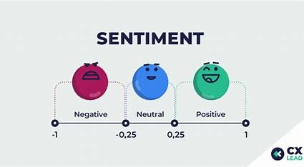

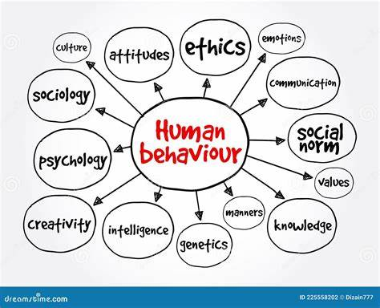

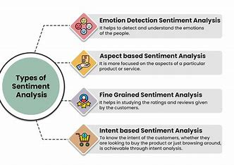

**METHODOLOGY:**

Three mainly used approaches for Sentiment Analysis include Lexicon Based Approach, Machine Learning Approach, and Hybrid Approach. In addition, researchers are continuously trying to figure out better ways to accomplish the task with better accuracy and lower computational cost. Overview various methods used in Sentiment Analysis as General Method about the Data collection, Feature selection and Sentiment analysis task are  which understand the overall scenario of sentiment analysis task and overall method workflow.

The majority of sentiment analysis in the modern day is data-driven machine learning models adapting a sentiment analysis algorithm developed for product evaluations to evaluate microblog postings is an unanswered question. Additionally, how to deal with ambiguous situations and irony are key difficulties in sentiment analysis. For instance, a sarcastic remark about an object is intended to communicate a negative sentiment; yet, conventional sentiment analysis algorithms frequently miss this meaning. Sentiment analysis is applicable to different types of data, each of which presents particular challenges. Sentiment analysis of human to machine and human to human interactions requires very similar datasets to those used for emotion recognition. As a result, it has the same limitations in terms of size and unreliable ground truth.

Multimedia information on websites is the second source of multi-modal sentiment data. Social media provides us with a wealth of data that helps us to scale. The issue is that the data acquired vary in terms of quality and context, and the data is limited to specific populations that are more prevalent on the internet. However, because the data is publicly available, crowd sourcing may be utilized to categorize it easily. According to the available data on MSA, people are more prone to communicate positive or negative ideas online, resulting in a scarcity of neutral opinions represented in all MSA studies evaluated.

**PREFORMANCE EVALUATION:**

The majority of state-of-the-art sentiment analysis makes use of accuracy, F1 score, and precision. Sentiment analysis using deep learning architectures: a review utilizes recall and accuracy as performance metrics. These metrics are as follows:

True Positive (TP): The number of positive reviews that have been correctly classified.

True Negative (TN): The number of negative reviews correctly classified as negative.

False Positive (FP): Number of incorrectly classified positive review.

False Negative (FN): Number of incorrectly classified negative review.

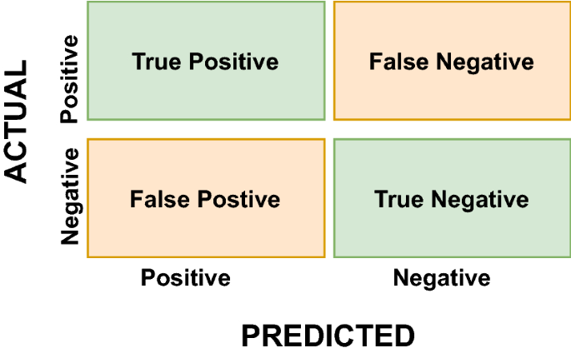

**DATA COLLECTIONS:**

Data can be collected from the internet via web scraping, social media, news channels, E-commerce websites, Forums, Weblog, some other websites shown in Fig. [2](https://link.springer.com/article/10.1007/s10462-022-10144-1#Fig2). Data Collection is the first stage in the Sentiment Analysis. Depending on task sentiment analysis of findings, text data can be combined with other types of data like video, audio, location, etc. A few essential sources of data collection are:

Social media: Social data refers to information gathered via social media networks. It demonstrates how consumers interact with the product by accessing, posting, and exchanging over.

Forms**:** Users can use message boards to discuss various topics, exchange opinions and ideas, and solicit assistance via text messages. Forums are an intriguing source for sentiment analysis due to the dynamic nature of user-generated information.

Weblog: A short weblog consists of paragraphs conveying a viewpoint, facts, personal diary entries, or links

Electronic commerce website: Electronic Commerce websites where users can give evaluations and express their opinions about a particular business or organization.

**CHALLENGES IN SENTIMENT ANALYSIS:**

Sentiment analysis comes with various challenges ranging from computational cost to informal writing and the presence of variations in languages. We look at the sentiment analysis challenges that occur more frequently with certain types of sentiment structure, as shown in Table [7](https://link.springer.com/article/10.1007/s10462-022-10144-1#Tab7). Few significant challenges faced in sentiment analysis are:

**STRUCTURED SENTIMENTS**:

Structured sentiments are found in formal sentiment reviews, they are more focused on formal problems such as books or research. Because the authors are professionals, they are capable of writing thoughts or observations concerning scientific or factual concerns.

**SEMI STRUTURED SENTIMENT:**

Semi-Structured Sentiments fall between structured and unstructured sentiments. These require an awareness of numerous review-related concerns. This style, which is dependent on benefits and drawbacks, is listed separately by the authors, and the pros and cons sections are typically comprised of brief sentences.

**UNSTRUTURED SENTIMENT:**

Unstructured Sentiment is an informal and free-flowing writing type in which the writer is not constrained by any rules (Mukherjee et al. [2013](https://link.springer.com/article/10.1007/s10462-022-10144-1#ref-CR154)). The text may comprise multiple sentences, each of which could potentially include both pros and cons. For example, unstructured reviews offer more opinion information than their formal counterparts (Levashina et al. [2014](https://link.springer.com/article/10.1007/s10462-022-10144-1#ref-CR126)).

**Objective:**

The objective of the project is to Recognize sentiment and behaviour in text data, including classifying sentiment as positive, negative, or neutral and analyzing sentiment intensity using python.

**Description:**

Identifying behavioural patterns or intents, such as customer satisfaction or purchase intent, as well as classifying emotions or attitudes, such as positive, negative, or neutral sentiments, are all part of Python's sentiment and behaviour recognition process. NLTK (Natural Language Toolkit) or spacy sentiment analysis packages, machine learning models, and natural language processing (NLP) approaches are frequently used in this procedure to extract insights from textual data.

1. **Dataset description:**

This code loads a CSV dataset called "sentiment_behavior_dataset.csv," imports the Pandas library, and shows the dataset's first few rows along with some basic metadata about its columns and data types.

1. **Drawbacks of existing system**:

Limited accuracy in identifying subtle emotions, problems with context understanding leading to misunderstandings, and limitations in managing sarcasm or irony, which might be widespread in text data, are some of the shortcomings of current sentiment and behaviour detection systems in Python.

1. **Justification for proposed algorithm:**

The suggested approach makes use of deep learning models for detailed analysis and high-performance outcomes, effectively classifying behavior and sentiment using sophisticated natural language processing techniques. Python's abundance of libraries and frameworks makes implementation simple and guarantees reliable speed and effective processing.

1. **Comparing proposed and existing algorithm:**

A concise technique for comparing the suggested and current Python-based sentiment and behaviour detection algorithms is to apply both approaches and assess their performance using the same dataset, looking at measures like accuracy, precision, recall, and F1-score. This makes it possible to compare their efficacy and efficiency in behaviour analysis and sentiment categorization tasks in a straightforward manner.

1. **Limitations and future scope:**

Accuracy can be impacted by handling sarcasm, context dependency, and complex language, which are among the constraints of sentiment and behaviour identification in NLP using Python. In order to comprehend and interpret complicated human emotions and actions more effectively, future scope will entail refining models using cutting-edge methods like multimodal analysis, transfer learning, and transformers.

**Code:**

import pandas as pd

import numpy as np

from sklearn.model_selection import train_test_split

from sklearn.ensemble import RandomForestClassifier

from sklearn.metrics import classification_report, accuracy_score

import matplotlib.pyplot as plt

import seaborn as sns

data = {

'user_id': np.random.randint(1, 100, 1000),

'activity': np.random.choice(['login', 'logout', 'purchase', 'browse'], 1000),

'timestamp': pd.date_range(start='1/1/2022', periods=1000, freq='H'),

'feature1': np.random.rand(1000),

'feature2': np.random.rand(1000),

'label': np.random.choice([0, 1], 1000)

}

df = pd.DataFrame(data)

X = df[['feature1', 'feature2']]

y = df['label']

X_train, X_test, y_train, y_test = train_test_split(X, y, test_size=0.3, random_state=42)

model = RandomForestClassifier(n_estimators=100, random_state=42)

model.fit(X_train, y_train)

y_pred = model.predict(X_test)

print("Accuracy:", accuracy_score(y_test, y_pred))

print("Classification Report:\n", classification_report(y_test, y_pred))

feature_importances = pd.DataFrame(model.feature_importances_,

index=X_train.columns, columns=['importance']).sort_values('importance', ascending=False)

sns.barplot(x=feature_importances.index, y=feature_importances['importance'])

plt.title('Feature Importance')

plt.show()

**Output:**

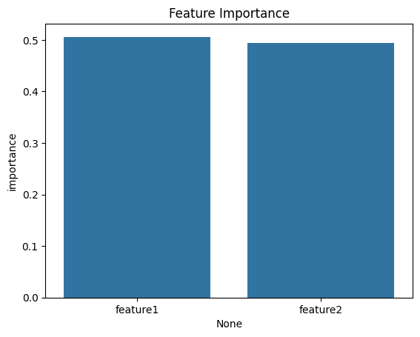

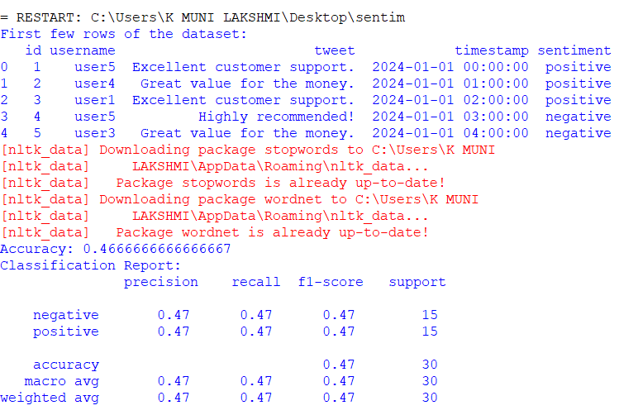

**CONCLUSION:**

This article discussed sentiment analysis and associated techniques. The primary objective of this work is to investigate and complete classification methods with their advantage and disadvantages in sentiment analysis. To begin, several levels of sentiment analysis were discussed, followed by a quick overview of necessary procedures such as data collection and feature selection. Next, methods of sentiment categorization systems were classified and compared in terms of their advantages and disadvantages. Due to their simplicity and excellent accuracy, supervised machine learning methods are often the widely utilized technique in this discipline. Classification using NB and SVM algorithms are commonly used as benchmarks against which newly proposed approaches can be compared. Several of the most common application areas are discussed then the survey examines the significance and consequences of sentiment analysis challenges in sentiment evaluation. The comparison investigates the relationship between the structure of sentiment reviews and the difficulties associated with sentiment analysis. This comparison reveals domain dependence, which is essential for identifying sentiment issues. The future work will consist of continuously expanding the comparison area with additional findings. The subsequent challenges illustrate that sentiment analysis is still a relatively unexplored subject of study

**REFERENCES:**

* Abid F, Alam M, Yasir M, Li C (2019) Sentiment analysis through recurrent variants latterly on convolutional neural network of twitter. Futur Gener Comput Syst 95:292–308
  + [**Article**](https://doi.org/10.1016%2Fj.future.2018.12.018)[**Google Scholar**](http://scholar.google.com/scholar_lookup?&title=Sentiment%20analysis%20through%20recurrent%20variants%20latterly%20on%20convolutional%20neural%20network%20of%20twitter&journal=Futur%20Gener%20Comput%20Syst&doi=10.1016%2Fj.future.2018.12.018&volume=95&pages=292-308&publication_year=2019&author=Abid%2CF&author=Alam%2CM&author=Yasir%2CM&author=Li%2CC)
* Acheampong FA, Wenyu C, Nunoo-Mensah H (2020) Text-based emotion detection: advances, challenges, and opportunities. Eng Rep 2(7):e12189
  + [**Google Scholar**](http://scholar.google.com/scholar_lookup?&title=Text-based%20emotion%20detection%3A%20advances%2C%20challenges%2C%20and%20opportunities&journal=Eng%20Rep&volume=2&issue=7&publication_year=2020&author=Acheampong%2CFA&author=Wenyu%2CC&author=Nunoo-Mensah%2CH)
* Acheampong FA, Nunoo-Mensah H, Chen W (2021) Transformer models for text-based emotion detection: a review of BERT-based approaches. Artif Intell Rev 54:5789–5829
  + [**Article**](https://link.springer.com/doi/10.1007/s10462-021-09958-2)[**Google Scholar**](http://scholar.google.com/scholar_lookup?&title=Transformer%20models%20for%20text-based%20emotion%20detection%3A%20a%20review%20of%20BERT-based%20approaches&journal=Artif%20Intell%20Rev&doi=10.1007%2Fs10462-021-09958-2&volume=54&pages=5789-5829&publication_year=2021&author=Acheampong%2CFA&author=Nunoo-Mensah%2CH&author=Chen%2CW)
* Adomavicius G, Kwon Y (2011) Improving aggregate recommendation diversity using ranking-based techniques. IEEE Trans Knowl Data Eng 24(5):896–911
  + [**Article**](https://doi.org/10.1109%2FTKDE.2011.15)[**Google Scholar**](http://scholar.google.com/scholar_lookup?&title=Improving%20aggregate%20recommendation%20diversity%20using%20ranking-based%20techniques&journal=IEEE%20Trans%20Knowl%20Data%20Eng&doi=10.1109%2FTKDE.2011.15&volume=24&issue=5&pages=896-911&publication_year=2011&author=Adomavicius%2CG&author=Kwon%2CY)
* Ahmad S, Asghar MZ, Alotaibi FM, Awan I (2019) Detection and classification of social media-based extremist affiliations using sentiment analysis techniques. Hum Centric Comput Inf Sci 9(1):1–23
  + [**Google Scholar**](http://scholar.google.com/scholar_lookup?&title=Detection%20and%20classification%20of%20social%20media-based%20extremist%20affiliations%20using%20sentiment%20analysis%20techniques&journal=Hum%20Centric%20Comput%20Inf%20Sci&volume=9&issue=1&pages=1-23&publication_year=2019&author=Ahmad%2CS&author=Asghar%2CMZ&author=Alotaibi%2CFM&author=Awan%2CI)
* Ahmad SR, Bakar AA, Yaakub MR (2019) A review of feature selection techniques in sentiment analysis. Intell Data Anal 23(1):159–189
  + [**Article**](https://doi.org/10.3233%2FIDA-173763)[**Google Scholar**](http://scholar.google.com/scholar_lookup?&title=A%20review%20of%20feature%20selection%20techniques%20in%20sentiment%20analysis&journal=Intell%20Data%20Anal&doi=10.3233%2FIDA-173763&volume=23&issue=1&pages=159-189&publication_year=2019&author=Ahmad%2CSR&author=Bakar%2CAA&author=Yaakub%2CMR)
* Akhtar MS, Ekbal A, Cambria E (2020) How intense are you? predicting intensities of emotions and sentiments using stacked ensemble [application notes]. IEEE Comput Intell Mag 15(1):64–75
  + [**Article**](https://doi.org/10.1109%2FMCI.2019.2954667)[**Google Scholar**](http://scholar.google.com/scholar_lookup?&title=How%20intense%20are%20you%3F%20predicting%20intensities%20of%20emotions%20and%20sentiments%20using%20stacked%20ensemble%20%5Bapplication%20notes%5D&journal=IEEE%20Comput%20Intell%20Mag&doi=10.1109%2FMCI.2019.2954667&volume=15&issue=1&pages=64-75&publication_year=2020&author=Akhtar%2CMS&author=Ekbal%2CA&author=Cambria%2CE)
* Akhtar N, Zubair N, Kumar A, Ahmad T (2017) Aspect based sentiment oriented summarization of hotel reviews. Procedia Comput Sci 115:563–571
  + [**Article**](https://doi.org/10.1016%2Fj.procs.2017.09.115)[**Google Scholar**](http://scholar.google.com/scholar_lookup?&title=Aspect%20based%20sentiment%20oriented%20summarization%20of%20hotel%20reviews&journal=Procedia%20Comput%20Sci&doi=10.1016%2Fj.procs.2017.09.115&volume=115&pages=563-571&publication_year=2017&author=Akhtar%2CN&author=Zubair%2CN&author=Kumar%2CA&author=Ahmad%2CT)
* Al Amrani Y, Lazaar M, El Kadiri KE (2018) Random forest and support vector machine based hybrid approach to sentiment analysis. Procedia Comput Sci 127:511–520
  + [**Article**](https://doi.org/10.1016%2Fj.procs.2018.01.150)[**Google Scholar**](http://scholar.google.com/scholar_lookup?&title=Random%20forest%20and%20support%20vector%20machine%20based%20hybrid%20approach%20to%20sentiment%20analysis&journal=Procedia%20Comput%20Sci&doi=10.1016%2Fj.procs.2018.01.150&volume=127&pages=511-520&publication_year=2018&author=Al%20Amrani%2CY&author=Lazaar%2CM&author=Kadiri%2CKE)
* Al-Smadi M, Qawasmeh O, Al-Ayyoub M, Jararweh Y, Gupta B (2018) Deep recurrent neural network vs. support vector machine for aspect-based sentiment analysis of Arabic hotels’ reviews. J Comput Sci 27:386–393
  + [**Article**](https://doi.org/10.1016%2Fj.jocs.2017.11.006)[**Google Scholar**](http://scholar.google.com/scholar_lookup?&title=Deep%20recurrent%20neural%20network%20vs.%20support%20vector%20machine%20for%20aspect-based%20sentiment%20analysis%20of%20Arabic%20hotels%E2%80%99%20reviews&journal=J%20Comput%20Sci&doi=10.1016%2Fj.jocs.2017.11.006&volume=27&pages=386-393&publication_year=2018&author=Al-Smadi%2CM&author=Qawasmeh%2CO&author=Al-Ayyoub%2CM&author=Jararweh%2CY&author=Gupta%2CB)
* Alhumoud SO, Al Wazrah AA (2021) Arabic sentiment analysis using recurrent neural networks: a review. Artif Intell Rev 55:707–748
  + [**Article**](https://link.springer.com/doi/10.1007/s10462-021-09989-9)[**Google Scholar**](http://scholar.google.com/scholar_lookup?&title=Arabic%20sentiment%20analysis%20using%20recurrent%20neural%20networks%3A%20a%20review&journal=Artif%20Intell%20Rev&doi=10.1007%2Fs10462-021-09989-9&volume=55&pages=707-748&publication_year=2021&author=Alhumoud%2CSO&author=Al%20Wazrah%2CAA)
* Ali SM, Noorian Z, Bagheri E, Ding C, Al-Obeidat F (2020) Topic and sentiment aware microblog summarization for twitter. J Intell Inf Syst 54(1):129–156
  + [**Article**](https://link.springer.com/doi/10.1007/s10844-018-0521-8)[**Google Scholar**](http://scholar.google.com/scholar_lookup?&title=Topic%20and%20sentiment%20aware%20microblog%20summarization%20for%20twitter&journal=J%20Intell%20Inf%20Syst&doi=10.1007%2Fs10844-018-0521-8&volume=54&issue=1&pages=129-156&publication_year=2020&author=Ali%2CSM&author=Noorian%2CZ&author=Bagheri%2CE&author=Ding%2CC&author=Al-Obeidat%2CF)
* Annett M, Kondrak G (2008) A comparison of sentiment analysis techniques: Polarizing movie blogs. In: Conference of the Canadian Society for Computational Studies of Intelligence. Springer, pp 25–35
* Arora A, Chakraborty P, Bhatia M, Mittal P (2021) Role of emotion in excessive use of twitter during COVID-19 imposed lockdown in India. J Technol Behav Sci 6(2):370–377
  + [**Article**](https://link.springer.com/doi/10.1007/s41347-020-00174-3)[**Google Scholar**](http://scholar.google.com/scholar_lookup?&title=Role%20of%20emotion%20in%20excessive%20use%20of%20twitter%20during%20COVID-19%20imposed%20lockdown%20in%20India&journal=J%20Technol%20Behav%20Sci&doi=10.1007%2Fs41347-020-00174-3&volume=6&issue=2&pages=370-377&publication_year=2021&author=Arora%2CA&author=Chakraborty%2CP&author=Bhatia%2CM&author=Mittal%2CP)
* Baashar Y, Alhussian H, Patel A, Alkawsi G, Alzahrani AI, Alfarraj O, Hayder G (2020) Customer relationship management systems (CRMS) in the healthcare environment: a systematic literature review. Comput Stand Interfaces 71:10344 [**Article**](https://doi.org/10.1016%2Fj.csi.2020.103442)[**Google Scholar**](http://scholar.google.com/scholar_lookup?&title=Customer%20relationship%20management%20systems%20%28CRMS%29%20in%20the%20healthcare%20environment%3A%20a%20systematic%20literature%20review&journal=Comput%20Stand%20Interfaces&doi=10.1016%2Fj.csi.2020.103442&volume=71&publication_year=2020&author=Baashar%2CY&author=Alhussian%2CH&author=Patel%2CA&author=Alkawsi%2CG&author=Alzahrani%2CAI&author=Alfarraj%2CO&author=Hayder%2CG)